Parent/Guardian Access to SHS Student Canvas
As a student, you can generate a pairing code to link an observer to your Canvas account. You must create a separate pairing code for each observer who wants to link to your account. An observer may be your parent, guardian, mentor, counselor, or another individual who needs to view your Canvas courses. Linked observers can view and participate in certain elements of your Canvas courses.
Student’s Roll
- Go to the Sequim High School Webpage. Scroll down and click on the CANVAS link or type in https://sequimschools.instructure.com/login/canvas
- After you log in, in Global Navigation, click the Account icon [1], then click the Settings link [2].
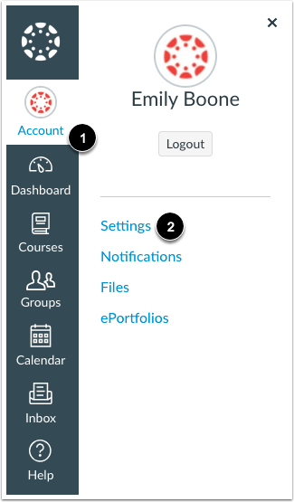

- Click the Pair with Observer button on the right bottom corner.
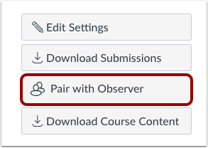
- Copy the six-digit alphanumeric pairing code [1]. You will need to share the code with the observer who will link to your account. The pairing code will expire after seven days or its first use. Note: Pairing codes are case sensitive.
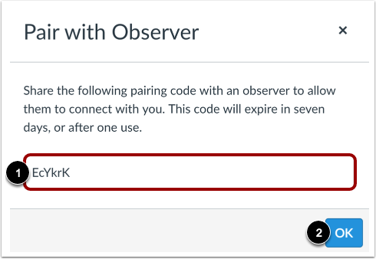

Parent/Guardian “Observer” Roll
- Go to the the Sequim High School Webpage. Scroll down and click on the CANVAS link or type in https://sequimschools.instructure.com/login/canvas
- Click on the “Click Here for an Account” link. Follow the steps by entering all pertinent information. Your student must provide you with a case sensitive pairing code.
